Asymmetric Wavy Shapes

Definition
# Source: AI Source: Provided by: [Data Path: Persons Table -> ID Column: 1, Name_En Column: Motasem Essam] -> From: [ChatGPT] on [7/25/2026]
An Asymmetric Wavy Shape is a wavy shape that does not remain unchanged under the specified symmetry transformation being considered.
Its corresponding parts do not match when subjected to that transformation.
For example, a wavy shape may have different wave sizes, spacing, or curvature on its two sides, so reflection across an axis does not reproduce the same shape.
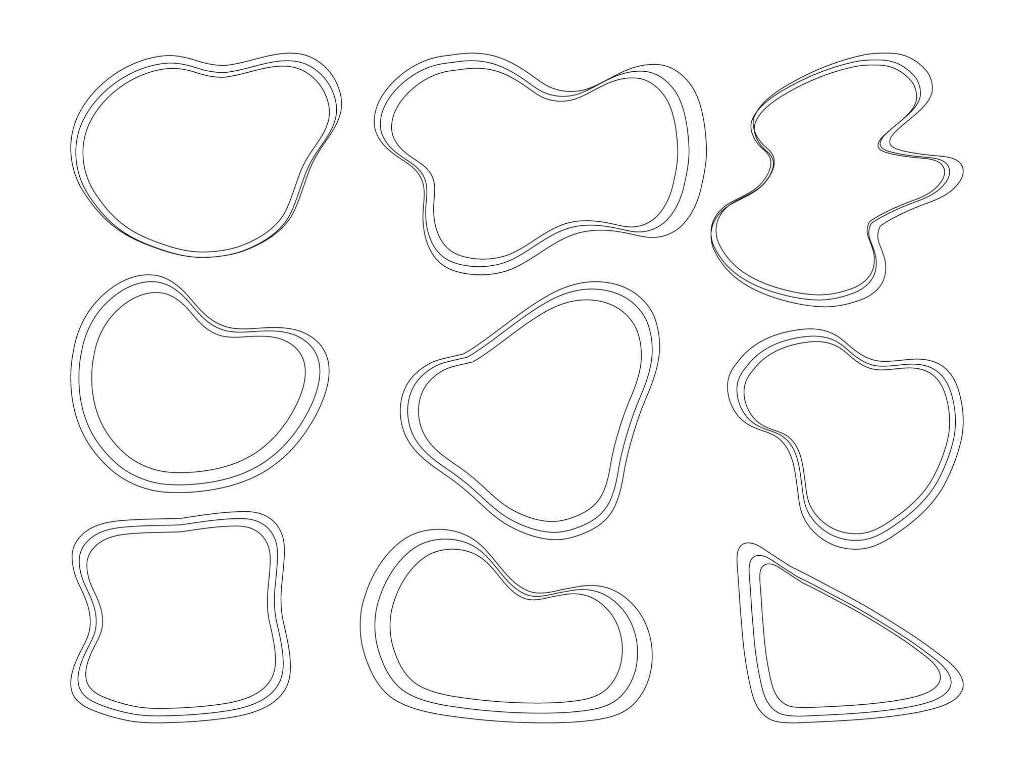
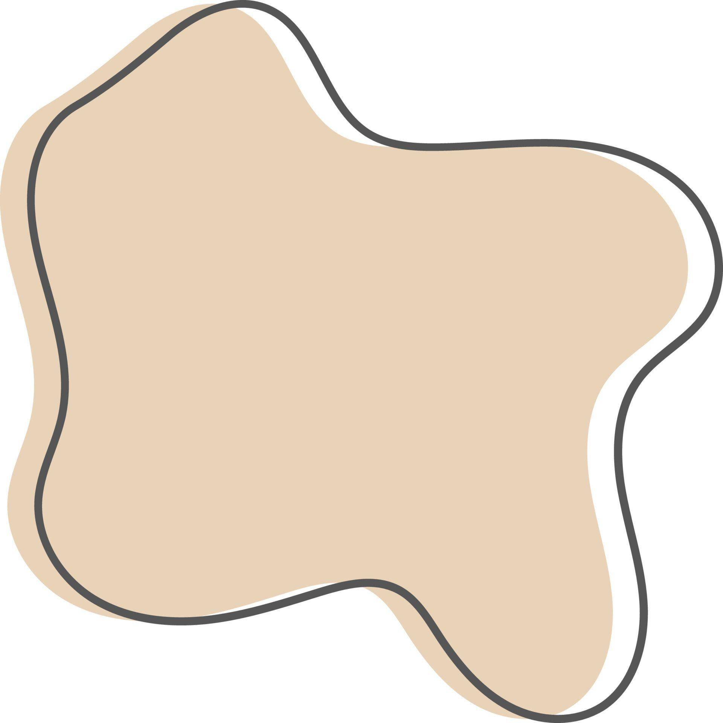
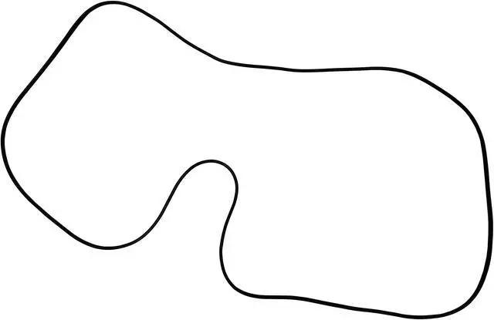
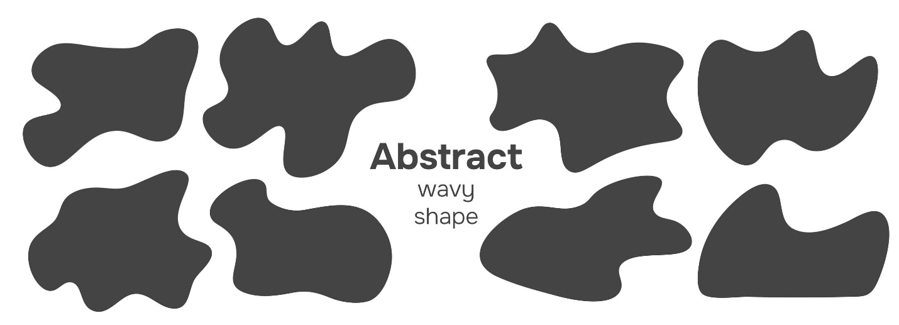
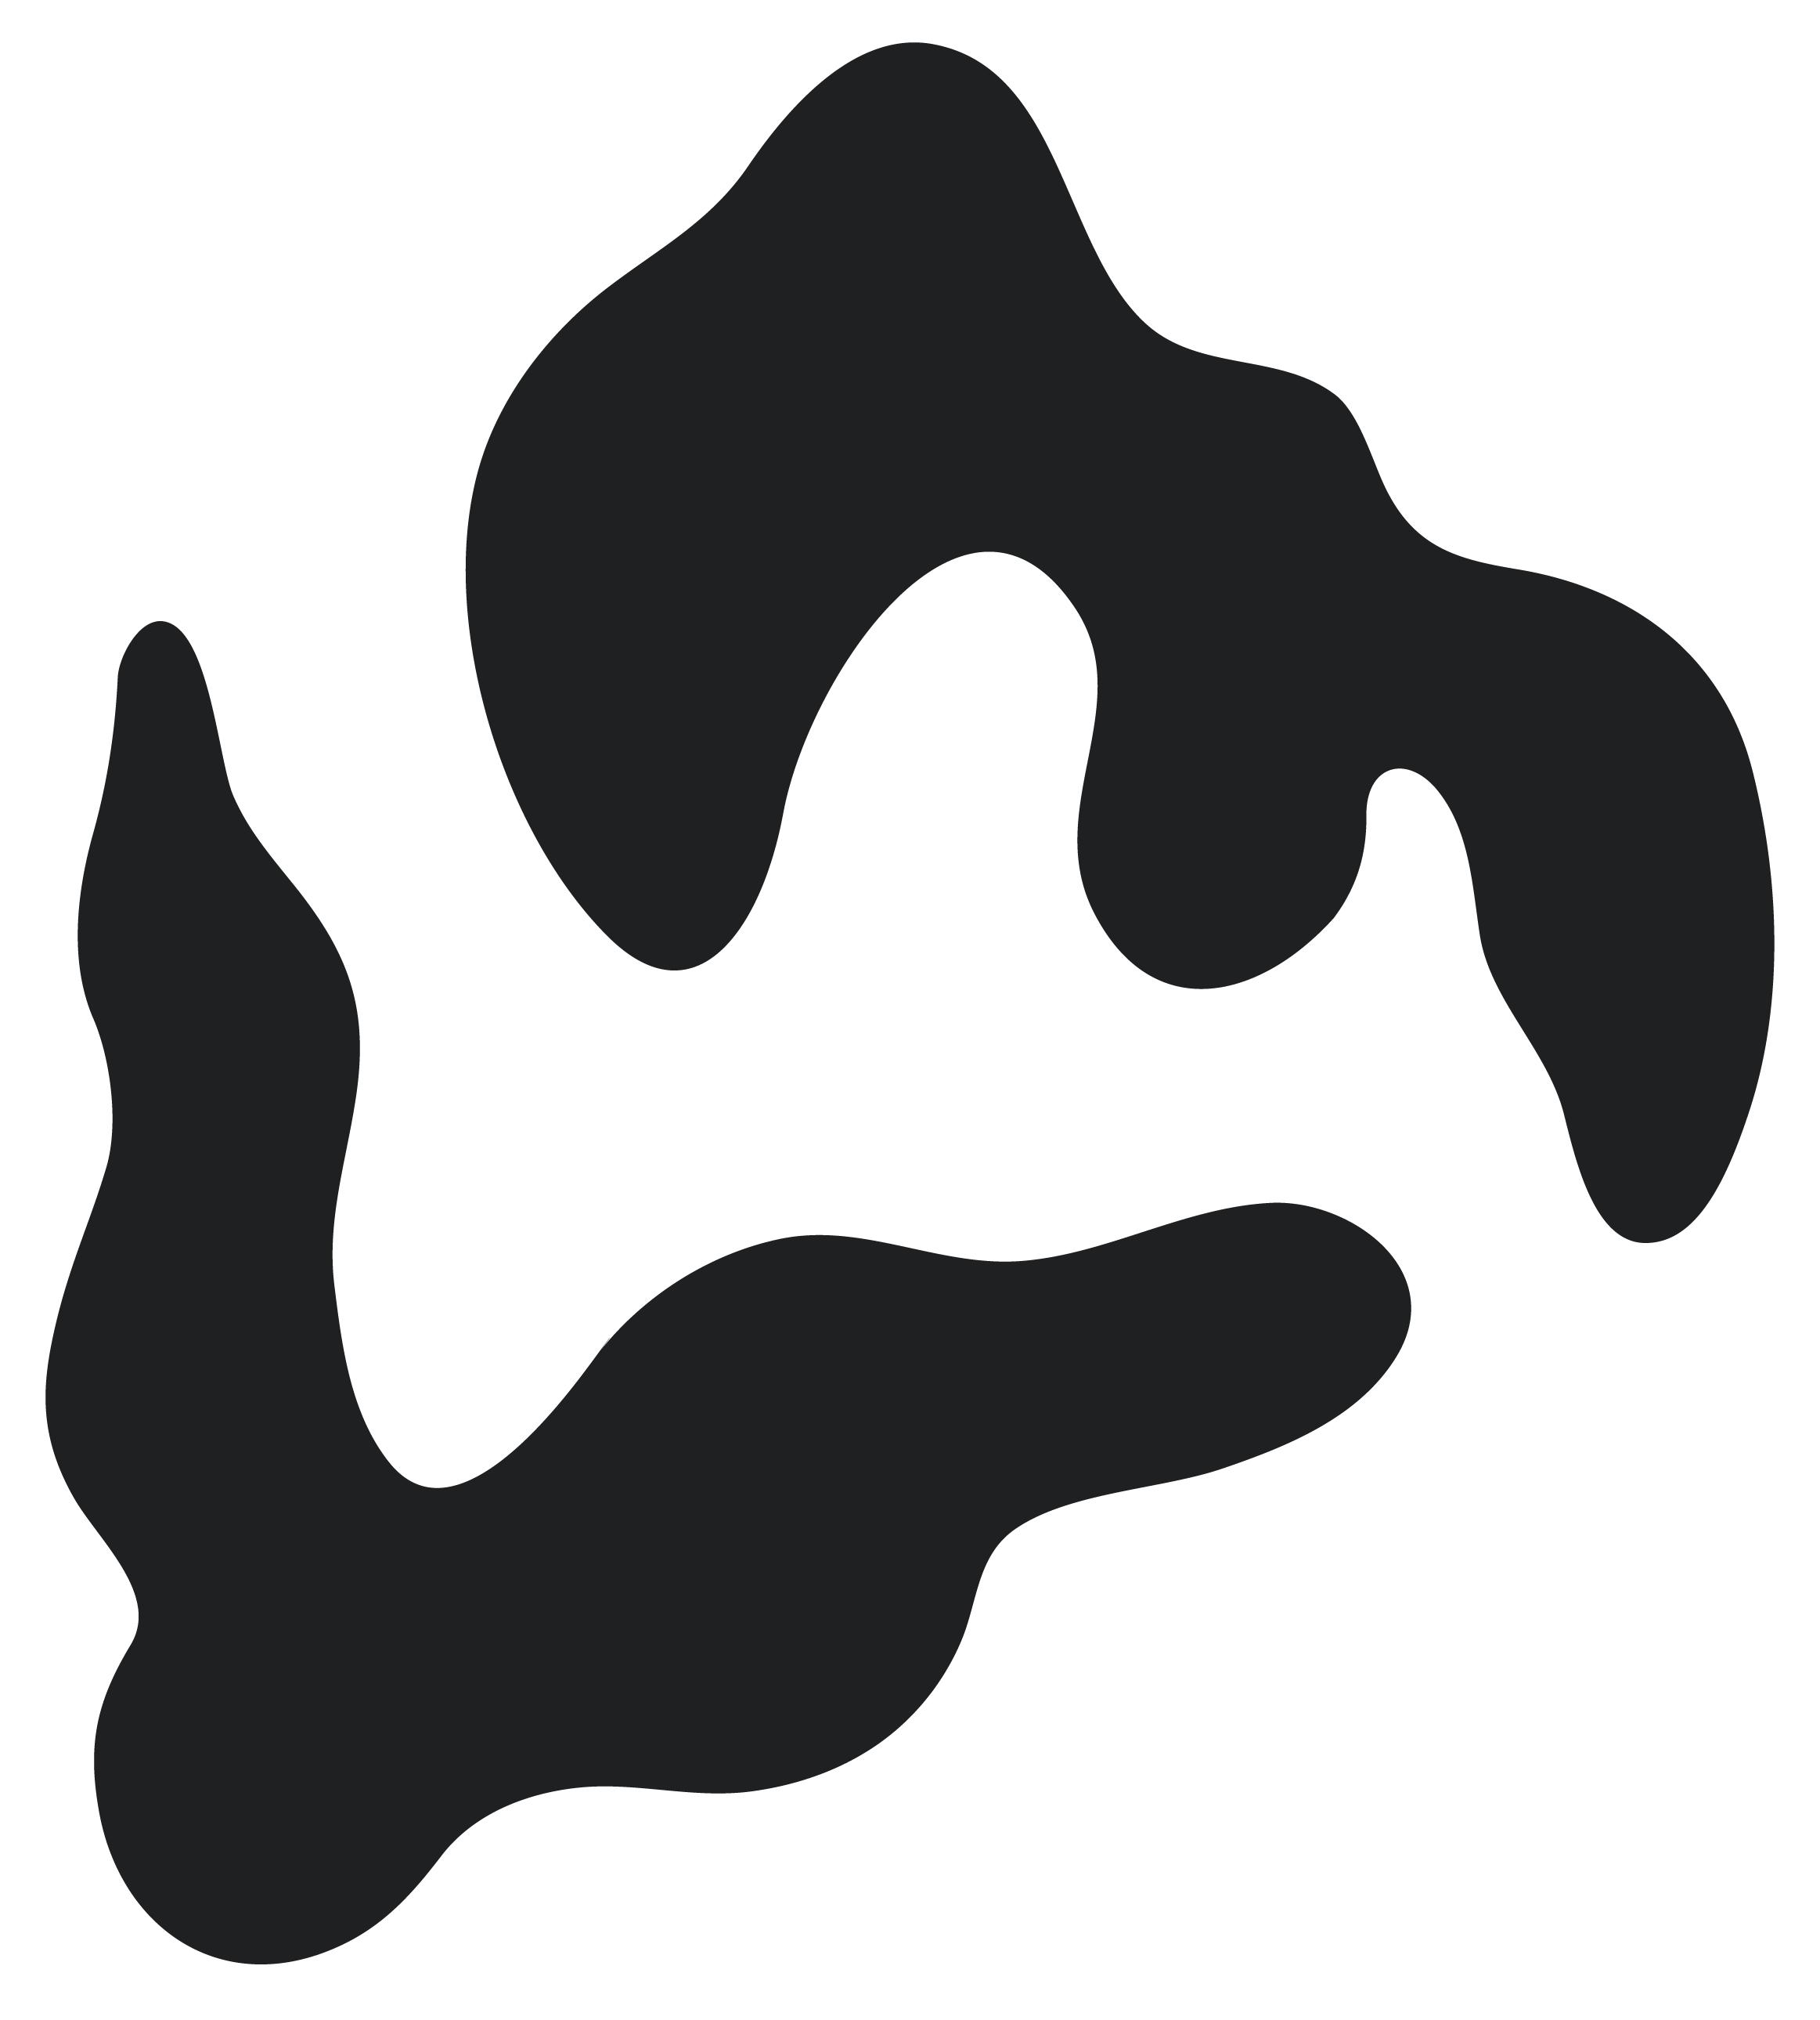
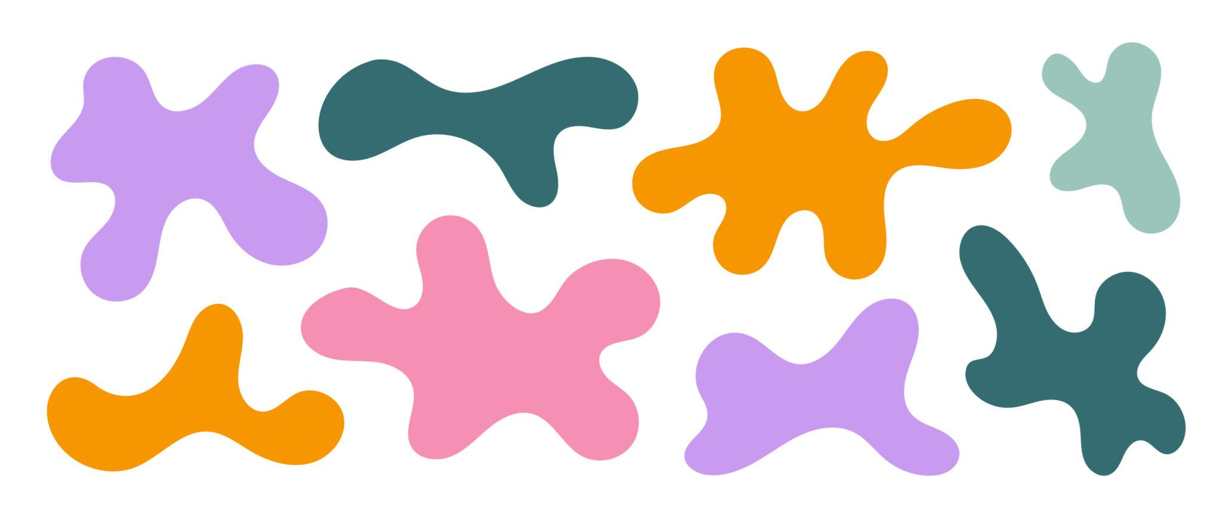

Fundamental Concept
# Source: AI Source: Provided by: [Data Path: Persons Table -> ID Column: 1, Name_En Column: Motasem Essam] -> From: [ChatGPT] on [7/25/2026]
The fundamental idea is lack of symmetry.
If $S$represents the shape and $T$represents a particular symmetry transformation, then an asymmetric shape does not satisfy:
$$T\left(S\right)=S$$
For example, for reflection across the $y$-axis:
$$\left(x , y\right)→\left(- , xy\right)$$
an asymmetric shape does not coincide with its reflected image.
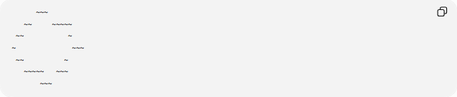
~~~
~~ ~~~~~
~~ ~
~ ~~~
~~ ~
~~~~~ ~~~
~~~
The two sides have different wave patterns.

Main Characteristics
# Source: AI Source: Provided by: [Data Path: Persons Table -> ID Column: 1, Name_En Column: Motasem Essam] -> From: [ChatGPT] on [7/25/2026]
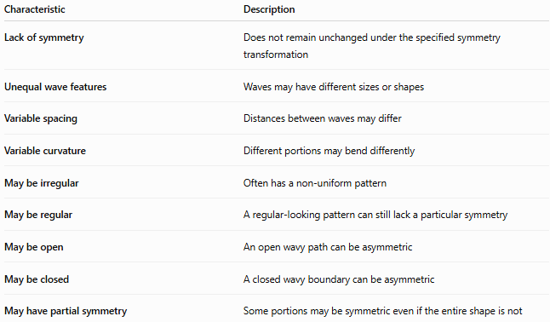
Characteristic | Description
Lack of symmetry | Does not remain unchanged under the specified symmetry transformation
Unequal wave features | Waves may have different sizes or shapes
Variable spacing | Distances between waves may differ
Variable curvature | Different portions may bend differently
May be irregular | Often has a non-uniform pattern
May be regular | A regular-looking pattern can still lack a particular symmetry
May be open | An open wavy path can be asymmetric
May be closed | A closed wavy boundary can be asymmetric
May have partial symmetry | Some portions may be symmetric even if the entire shape is not

Basic Structure
# Source: AI Source: Provided by: [Data Path: Persons Table -> ID Column: 1, Name_En Column: Motasem Essam] -> From: [ChatGPT] on [7/25/2026]
An asymmetric wavy shape can be represented using a general function:
$$y=f\left(x\right)$$
There is no requirement that
$$f\left(-x\right)=f\left(x\right)$$
or
$$f\left(-x\right)=-f\left(x\right)$$
Therefore, the curve does not necessarily have reflection or point symmetry about the origin.
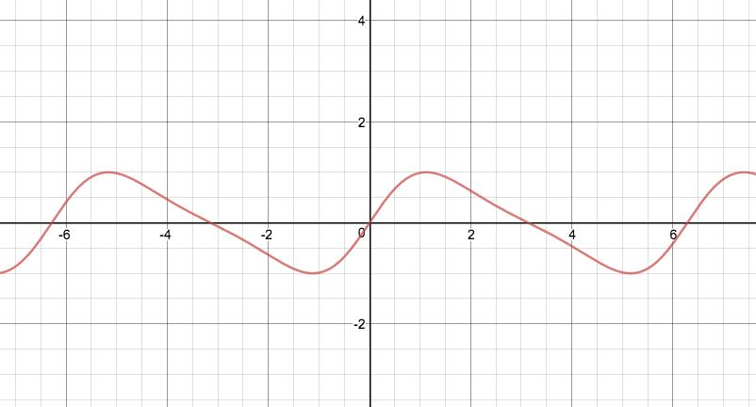
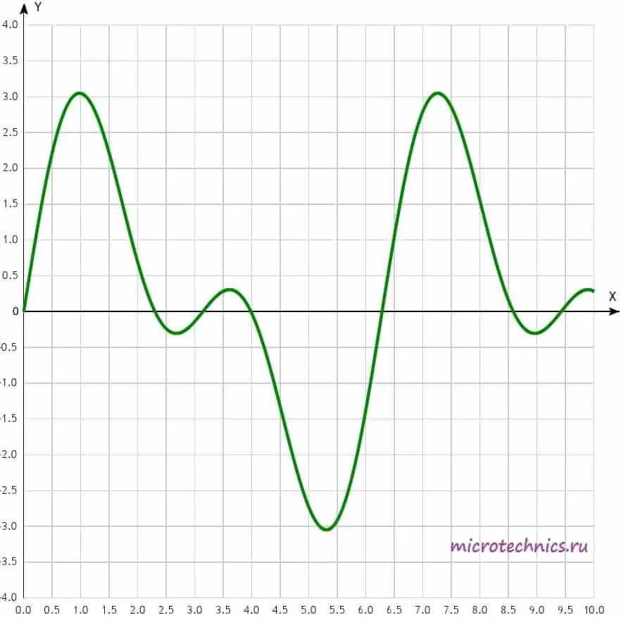
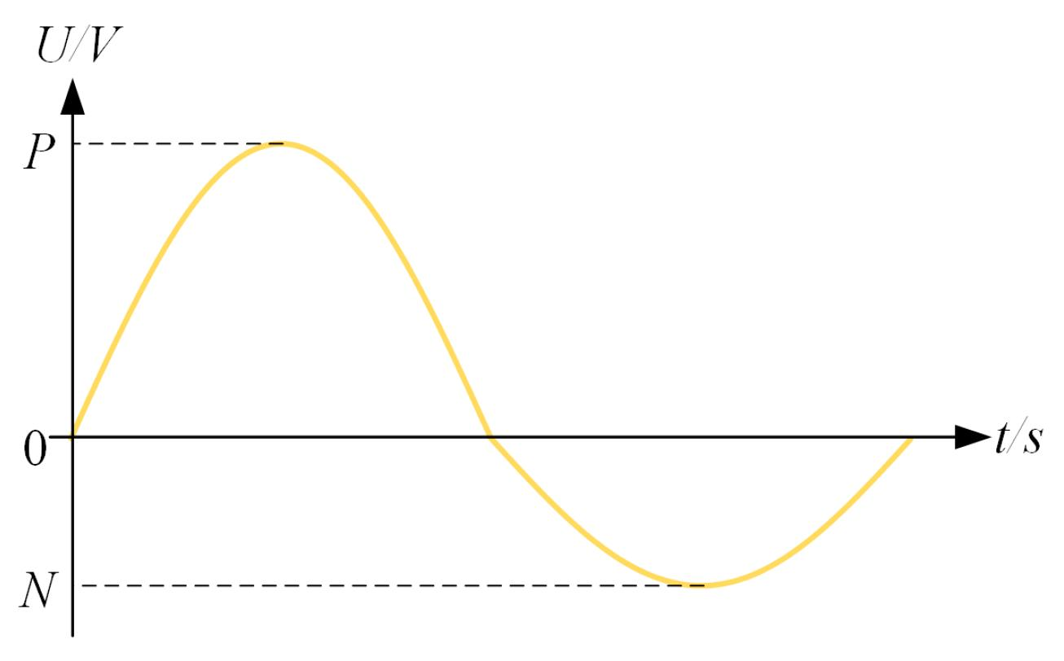

Types of Asymmetric Wavy Shapes

1-Asymmetric Open Wavy Shapes
# Source: AI Source: Provided by: [Data Path: Persons Table -> ID Column: 1, Name_En Column: Motasem Essam] -> From: [ChatGPT] on [7/25/2026]
An Asymmetric Open Wavy Shape is an open wavy path that lacks the specified symmetry.
It has:
- Two endpoints.
- No enclosed region by itself.
- A non-matching arrangement of corresponding wave features.
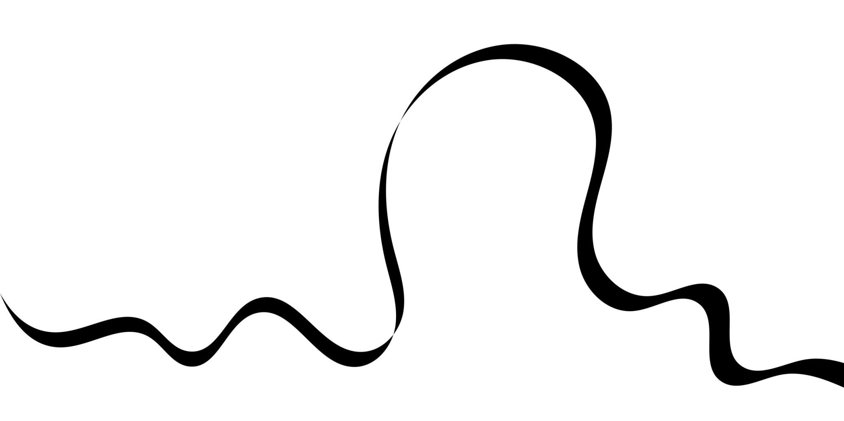
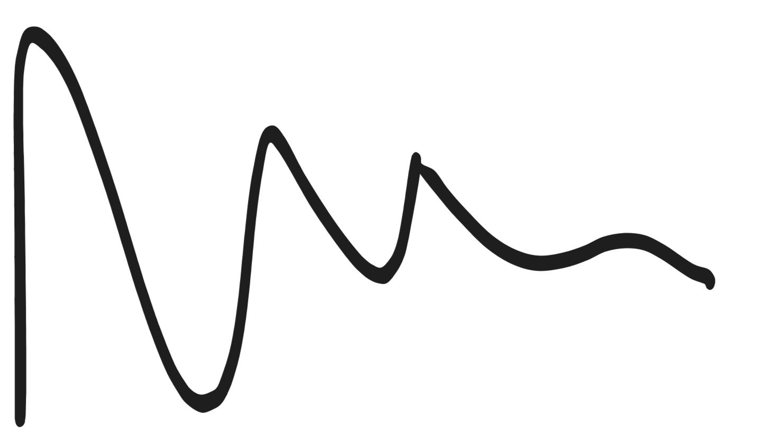
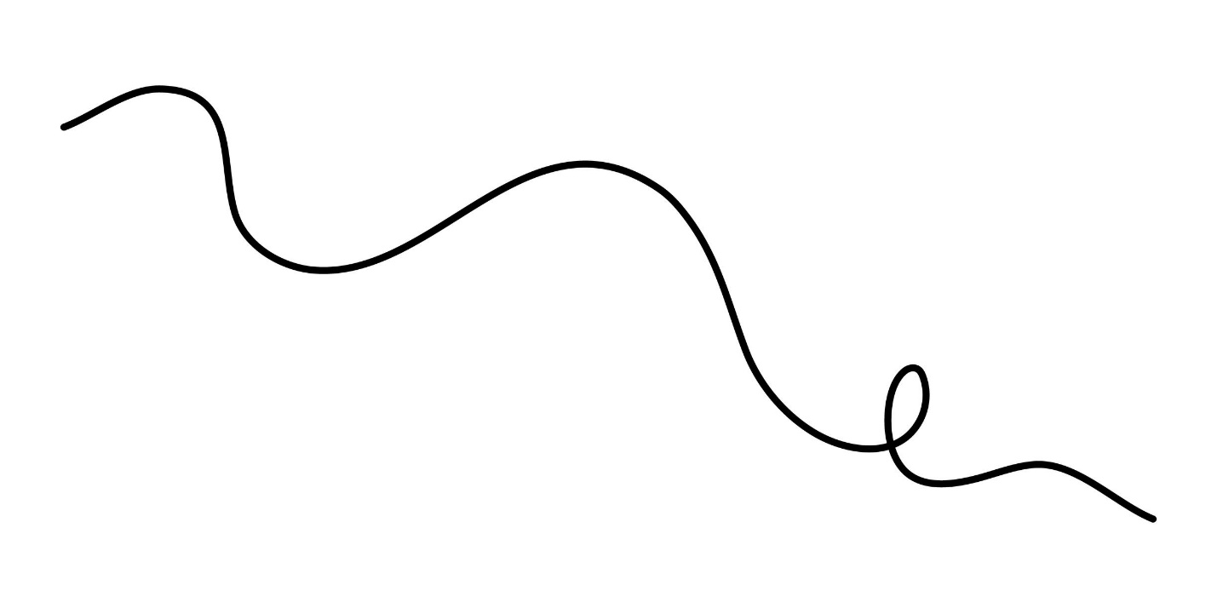
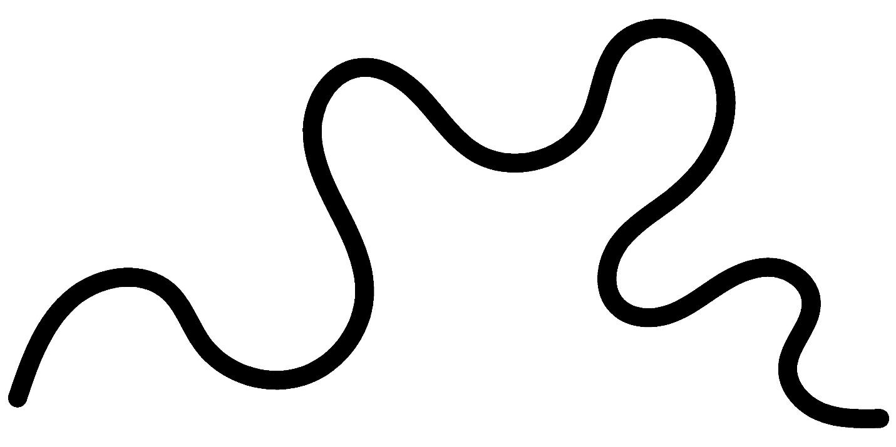
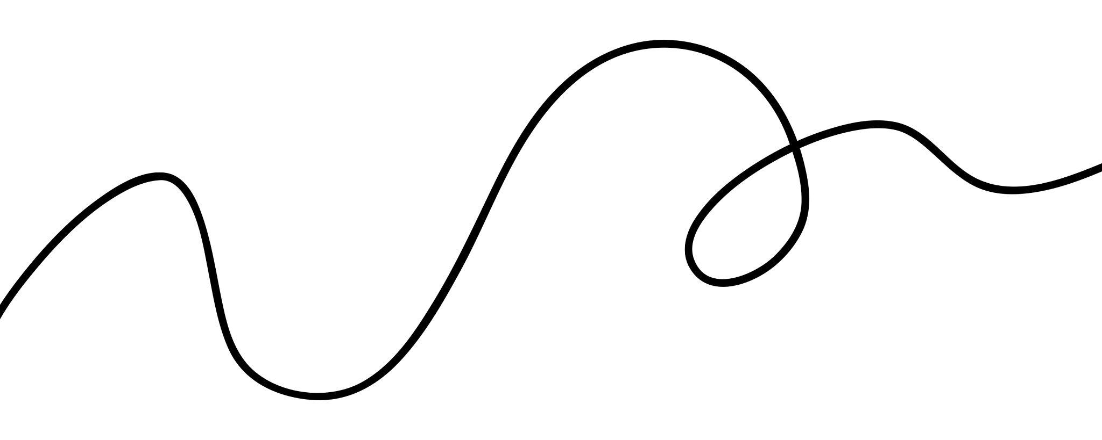
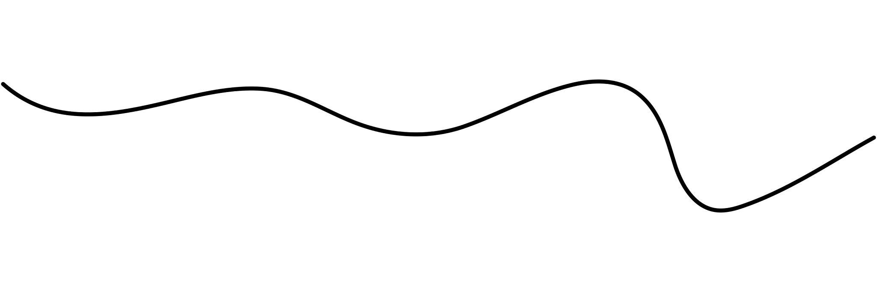
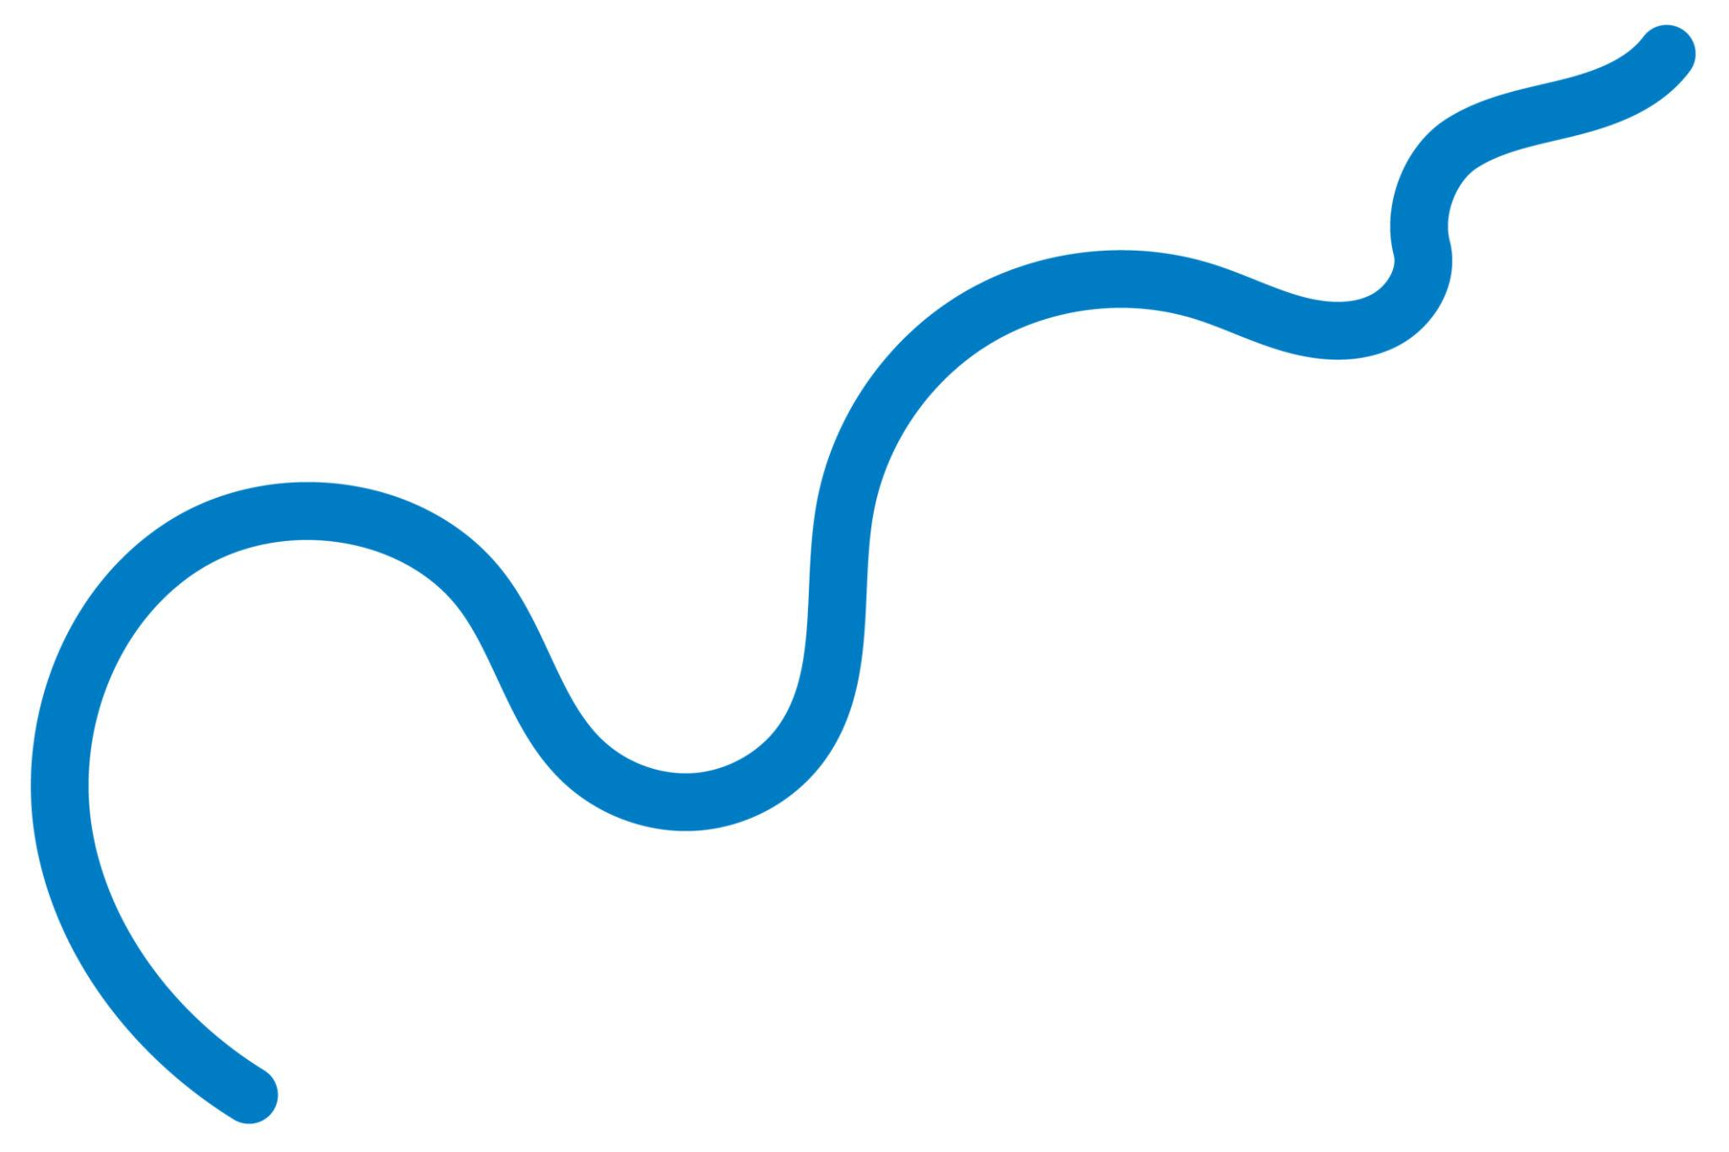

2-Asymmetric Closed Wavy Shapes
# Source: AI Source: Provided by: [Data Path: Persons Table -> ID Column: 1, Name_En Column: Motasem Essam] -> From: [ChatGPT] on [7/25/2026]
An Asymmetric Closed Wavy Shape has a continuous closed boundary but lacks the specified symmetry.
It can enclose an area while having different wave patterns around different portions of its boundary.
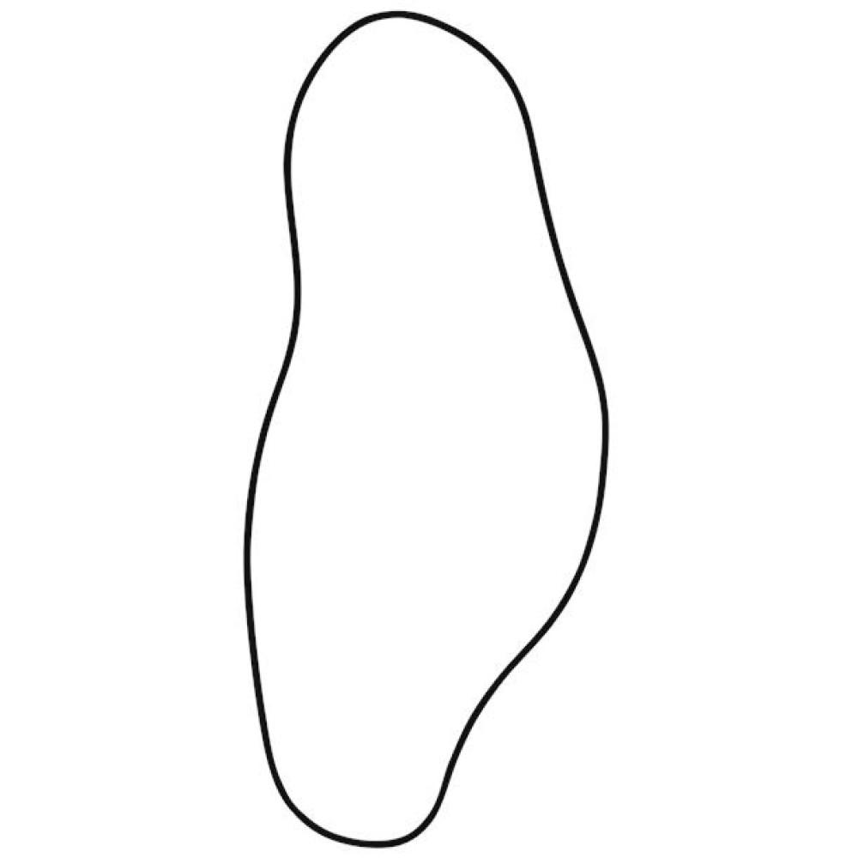
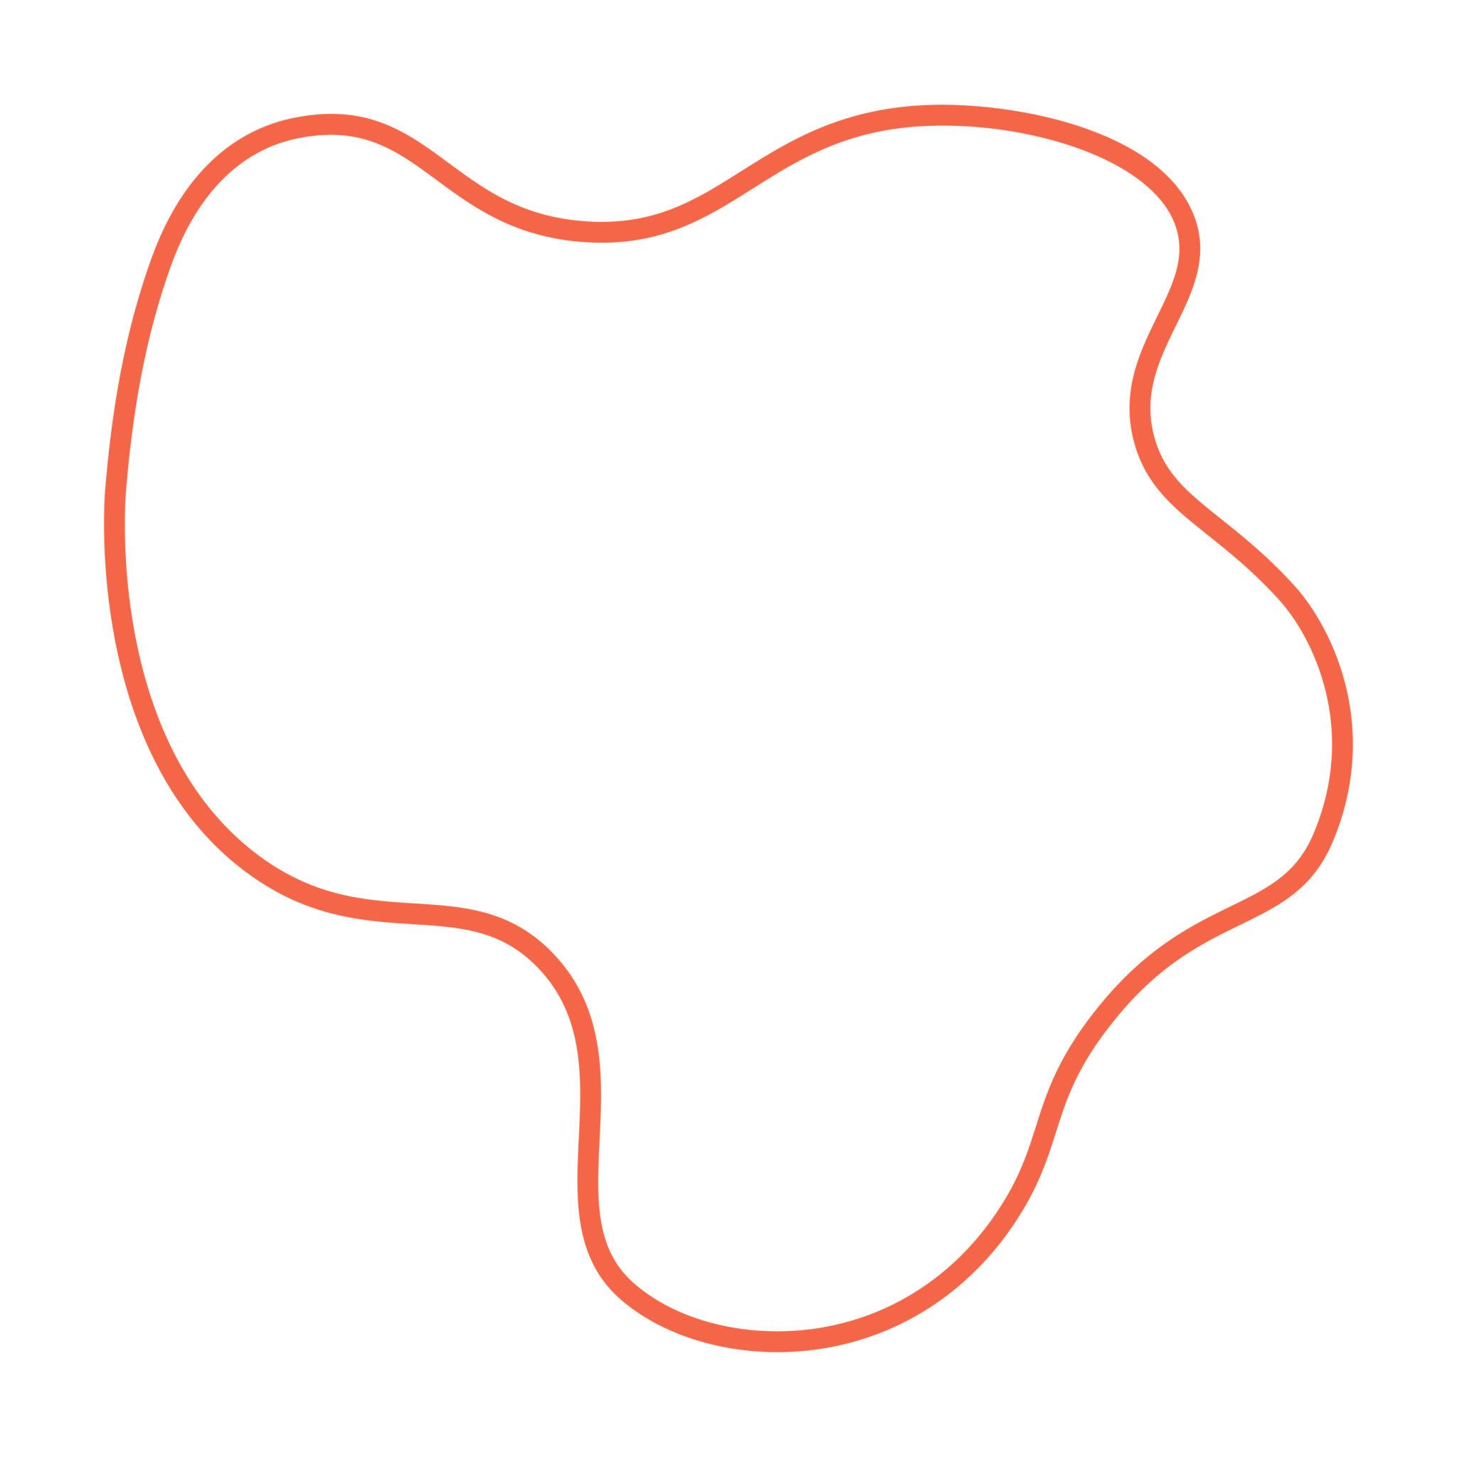
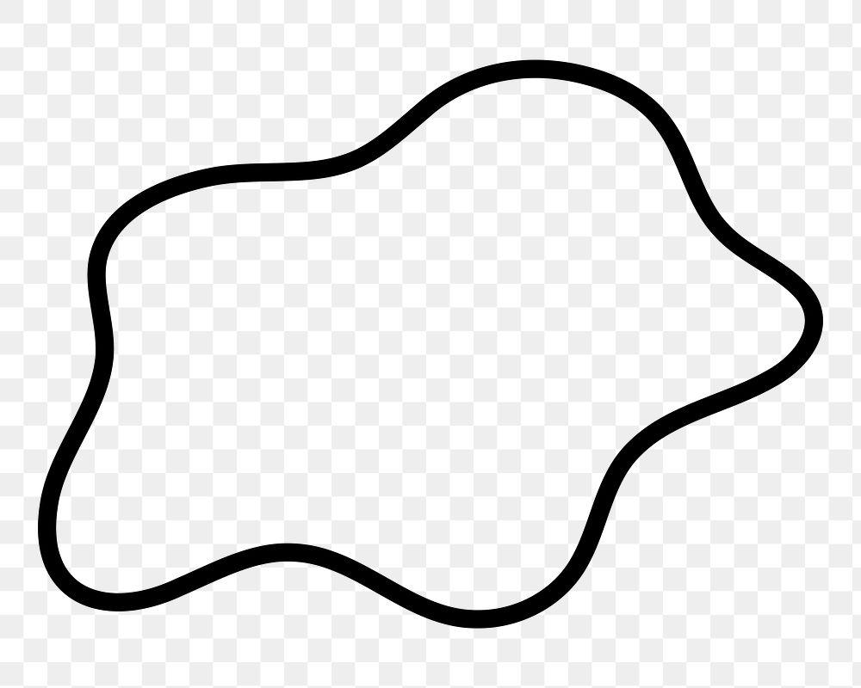
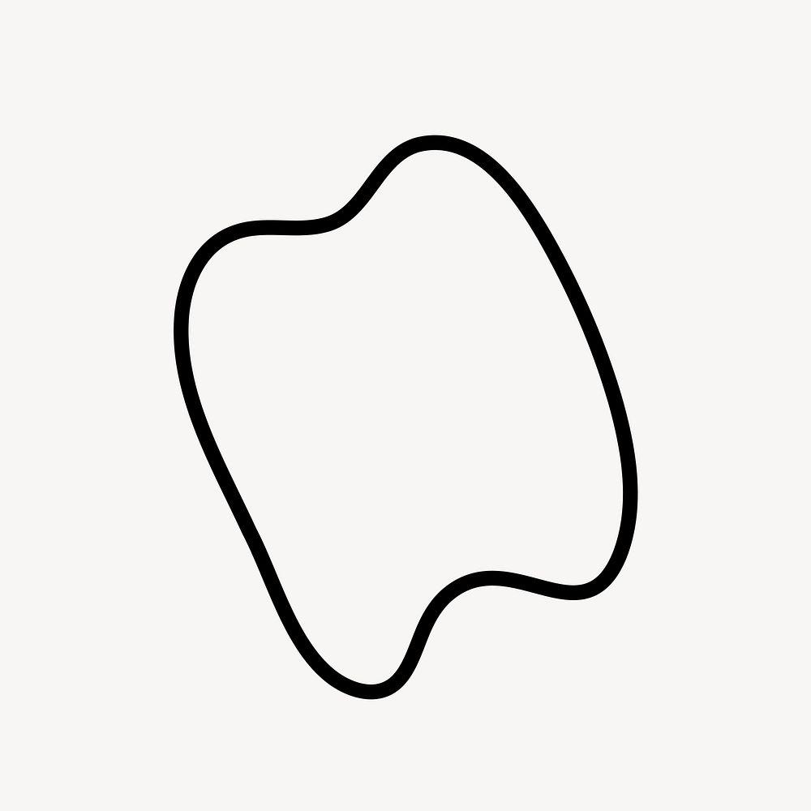

3-Irregular Asymmetric Wavy Shapes
# Source: AI Source: Provided by: [Data Path: Persons Table -> ID Column: 1, Name_En Column: Motasem Essam] -> From: [ChatGPT] on [7/25/2026]
An Irregular Asymmetric Wavy Shape combines two properties:
- Irregularity — its waves are non-uniform.
- Asymmetry — it lacks the specified symmetry.
For example, its left and right sides may have different:
- Wave heights.
- Wave widths.
- Curvatures.
- Spacing.
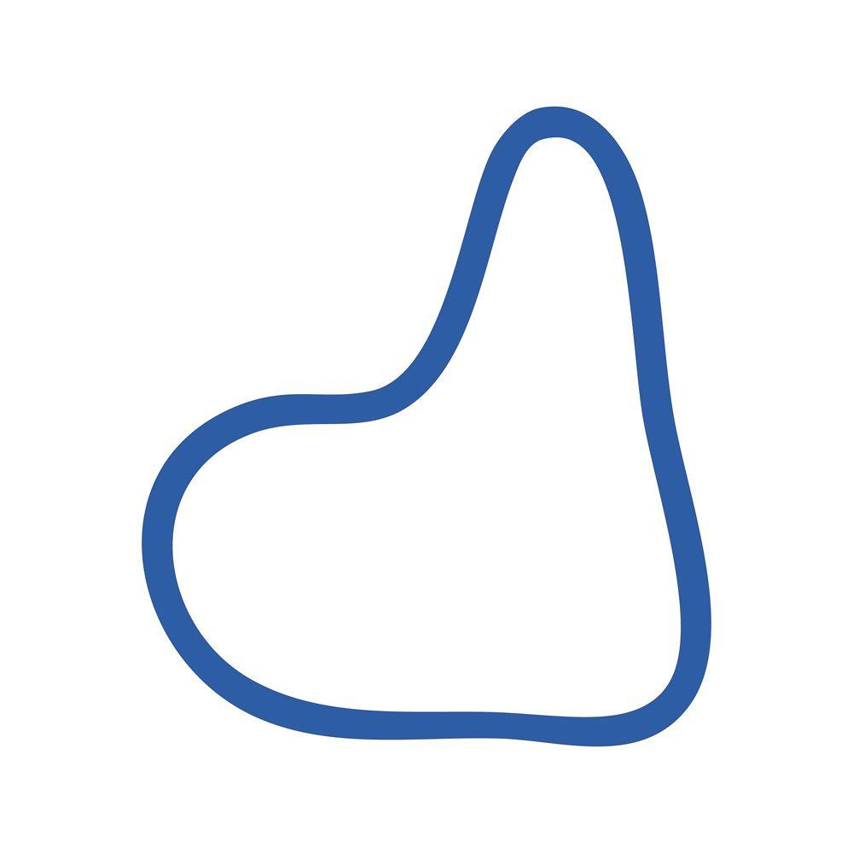
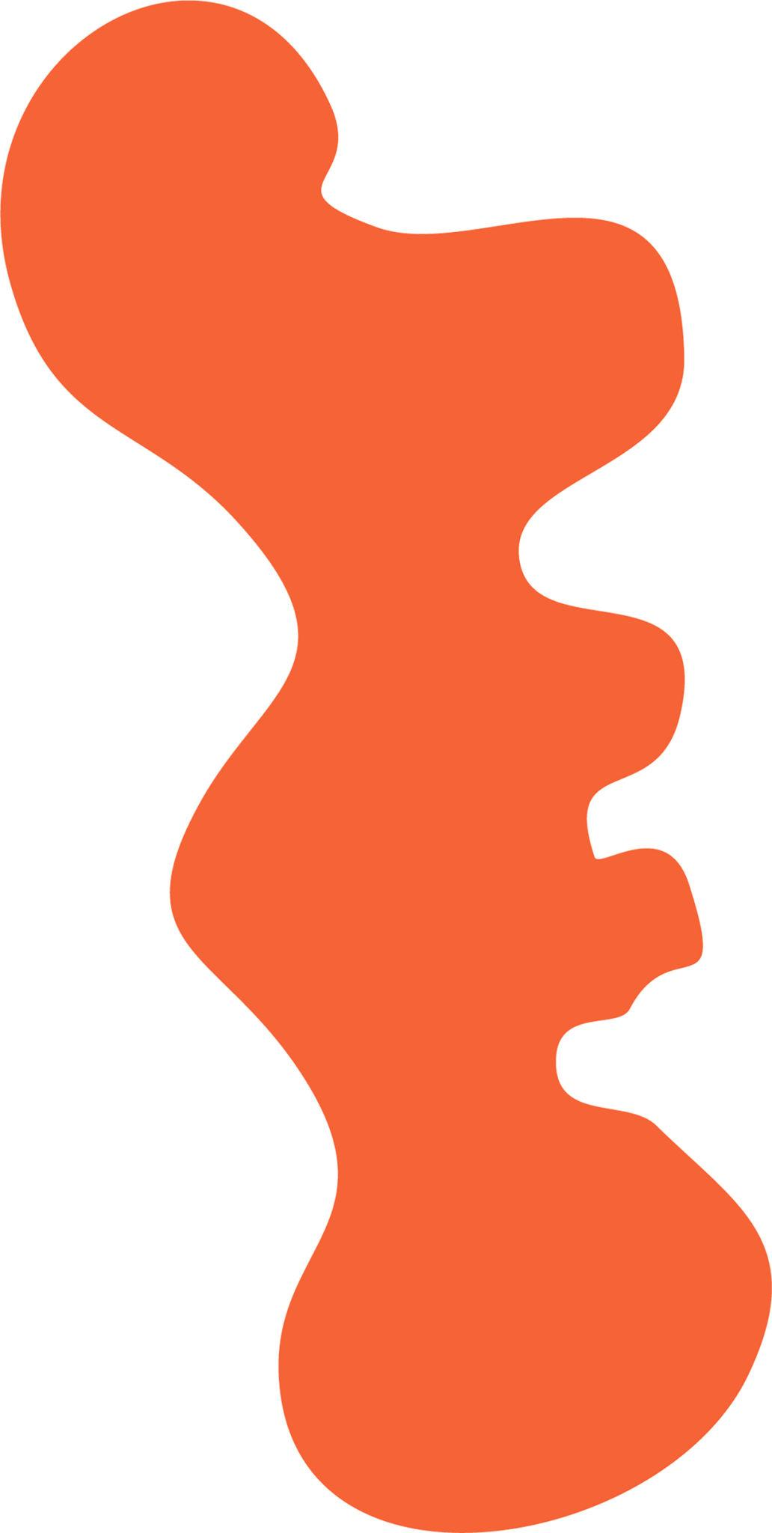
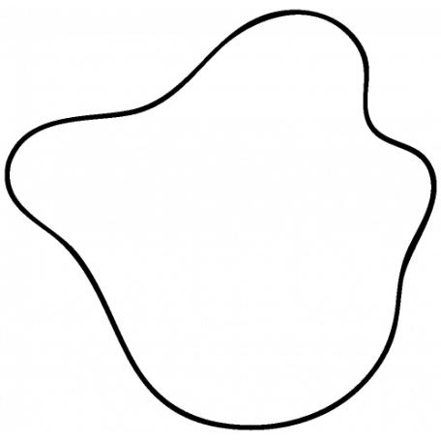

4-Regular Asymmetric Wavy Shapes
# Source: AI Source: Provided by: [Data Path: Persons Table -> ID Column: 1, Name_En Column: Motasem Essam] -> From: [ChatGPT] on [7/25/2026]
A Regular Asymmetric Wavy Shape has a consistent or repeating wave pattern but does not possess the symmetry being considered.
For example, a repeating wave may be arranged with a directional or phase offset that prevents reflection symmetry.
Thus:
Regularity does not automatically imply symmetry.
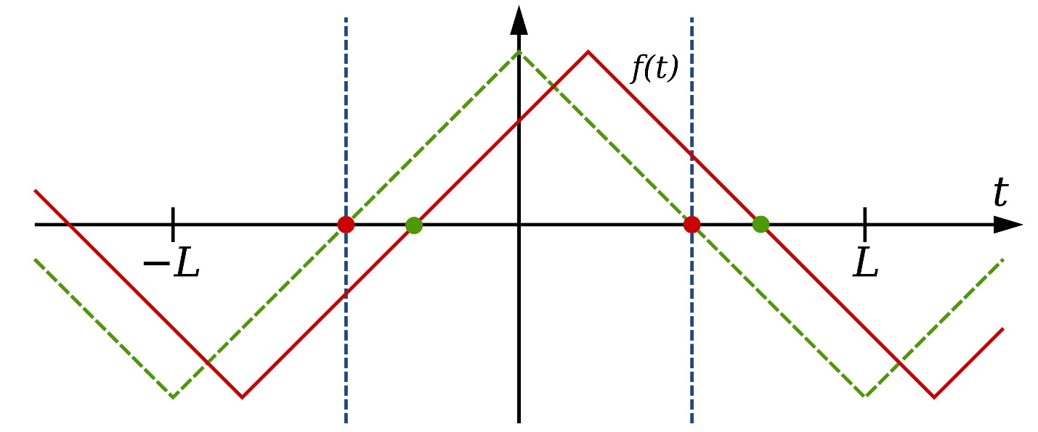

5-Freeform Asymmetric Wavy Shapes
# Source: AI Source: Provided by: [Data Path: Persons Table -> ID Column: 1, Name_En Column: Motasem Essam] -> From: [ChatGPT] on [7/25/2026]
A Freeform Asymmetric Wavy Shape has a freely varying curved boundary without a fixed standard geometric pattern and without the specified symmetry.
These are common in:
- Artistic forms.
- Decorative shapes.
- Organic forms.
- Abstract designs.
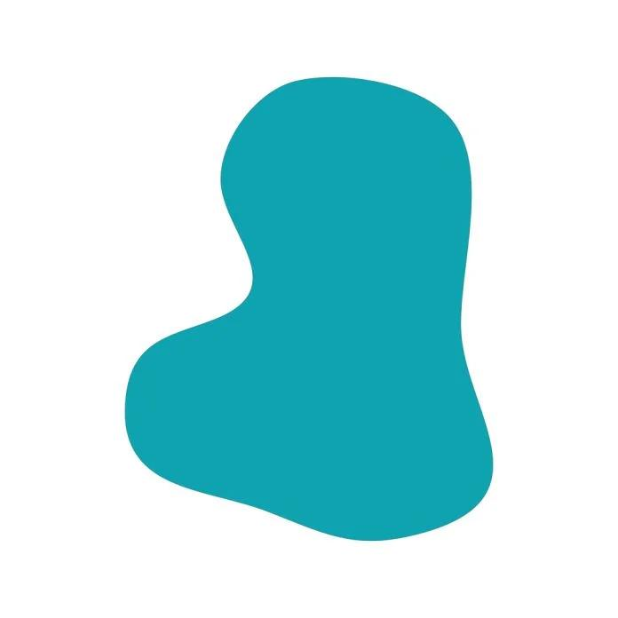
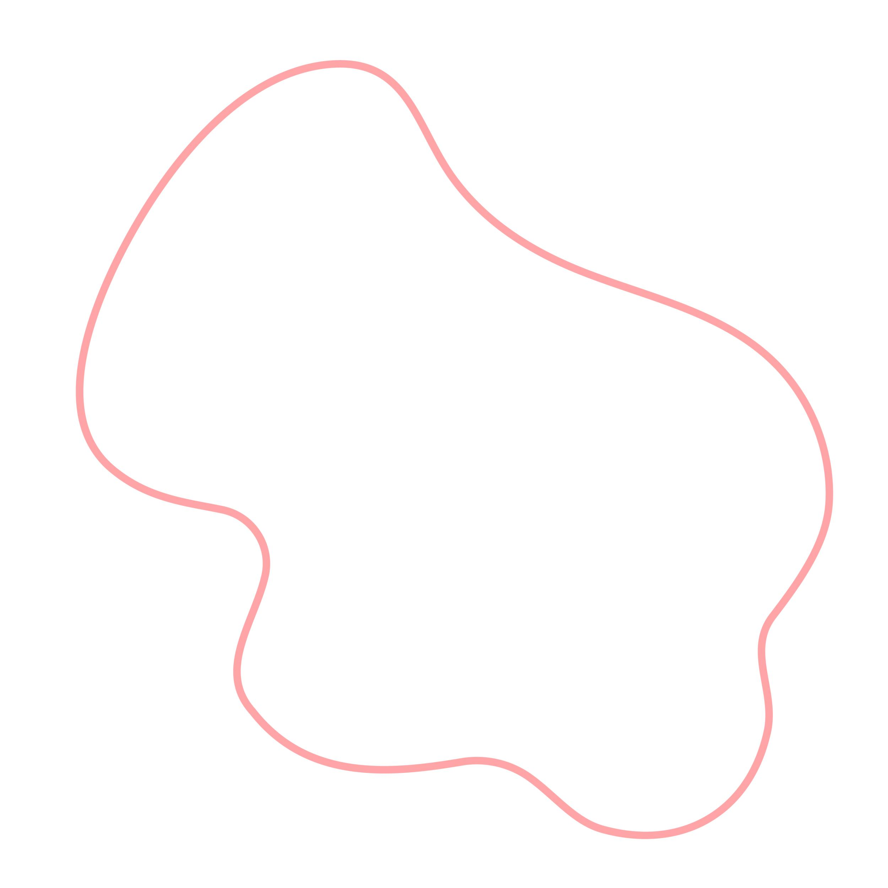
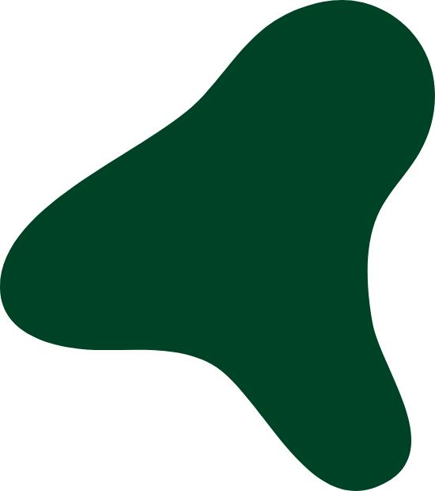
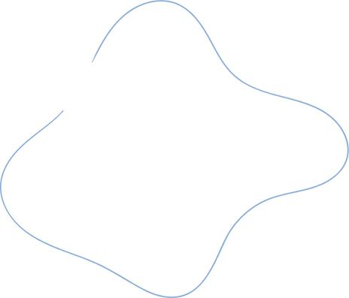

6-Partially Symmetric Wavy Shapes
# Source: AI Source: Provided by: [Data Path: Persons Table -> ID Column: 1, Name_En Column: Motasem Essam] -> From: [ChatGPT] on [7/25/2026]
A Partially Symmetric Wavy Shape contains a symmetric portion but the complete shape does not possess that symmetry.
For example:
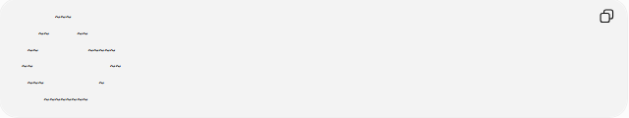
~~~
~~ ~~
~~ ~~~~~
~~ ~~
~~~ ~
~~~~~~~~
One section may have a mirrored structure while another section breaks the symmetry.
This is better described as partially symmetric rather than completely asymmetric if meaningful symmetry exists in part of the shape.

Mathematical Properties

Reflection Symmetry Test
# Source: AI Source: Provided by: [Data Path: Persons Table -> ID Column: 1, Name_En Column: Motasem Essam] -> From: [ChatGPT] on [7/25/2026]
For symmetry about the $y$-axis, a function must satisfy:
$$f\left(-x\right)=f\left(x\right)$$
If this condition is not satisfied, the graph does not have $y$-axis reflection symmetry.

Point Symmetry Test
# Source: AI Source: Provided by: [Data Path: Persons Table -> ID Column: 1, Name_En Column: Motasem Essam] -> From: [ChatGPT] on [7/25/2026]
For point symmetry about the origin:
$$f\left(-x\right)=-f\left(x\right)$$
If this condition is not satisfied, the graph does not have origin point symmetry.

General Symmetry Condition
# Source: AI Source: Provided by: [Data Path: Persons Table -> ID Column: 1, Name_En Column: Motasem Essam] -> From: [ChatGPT] on [7/25/2026]
More generally, if $T$is a transformation and $S$is the shape:
$$T\left(S\right)=S$$
means the shape has that symmetry.
If:
$$T\left(S\right)≠S$$
then the shape does not have that particular symmetry.
This distinction is important because asymmetry should normally be stated relative to the symmetry transformation being considered.

Boundary Length
# Source: AI Source: Provided by: [Data Path: Persons Table -> ID Column: 1, Name_En Column: Motasem Essam] -> From: [ChatGPT] on [7/25/2026]
For a parametric asymmetric wavy curve
$$r\left(t\right)=\left(x , \left(t\right)y\left(t\right)\right)$$
the boundary length is:
$$L=\int_{a}^{b}{\sqrt{{\left(\frac{dx}{dt}\right)}^{2}+{\left(\frac{dy}{dt}\right)}^{2}}} dt$$
For a closed curve, the parameter interval completes the entire boundary.

Enclosed Area
# Source: AI Source: Provided by: [Data Path: Persons Table -> ID Column: 1, Name_En Column: Motasem Essam] -> From: [ChatGPT] on [7/25/2026]
If the asymmetric wavy shape is closed, its area can be calculated using:
$$A=\frac{1}{2}\oint{(}\left.x dy-y dx\right)$$
The lack of symmetry does not prevent the calculation of area.

Asymmetric vs Symmetric Wavy Shapes
# Source: AI Source: Provided by: [Data Path: Persons Table -> ID Column: 1, Name_En Column: Motasem Essam] -> From: [ChatGPT] on [7/25/2026]
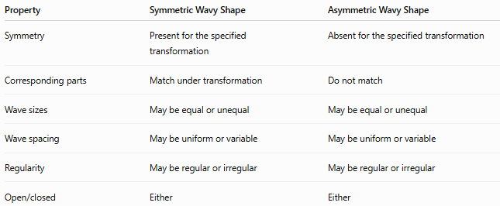
Property | Symmetric Wavy Shape | Asymmetric Wavy Shape
Symmetry | Present for the specified transformation | Absent for the specified transformation
Corresponding parts | Match under transformation | Do not match
Wave sizes | May be equal or unequal | May be equal or unequal
Wave spacing | May be uniform or variable | May be uniform or variable
Regularity | May be regular or irregular | May be regular or irregular
Open/closed | Either | Either
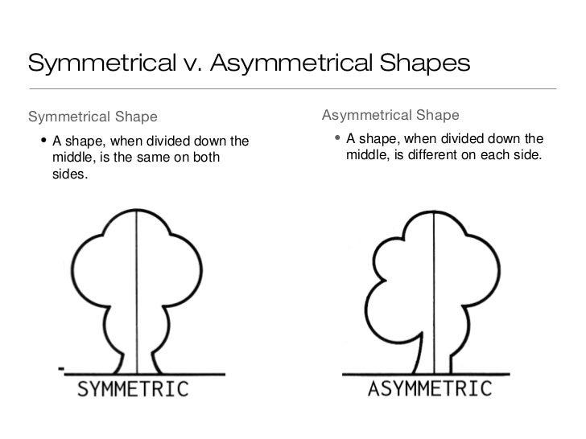
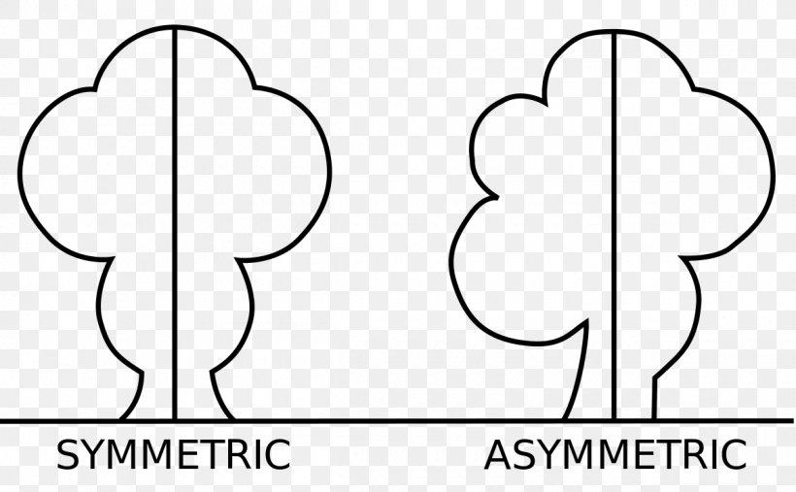
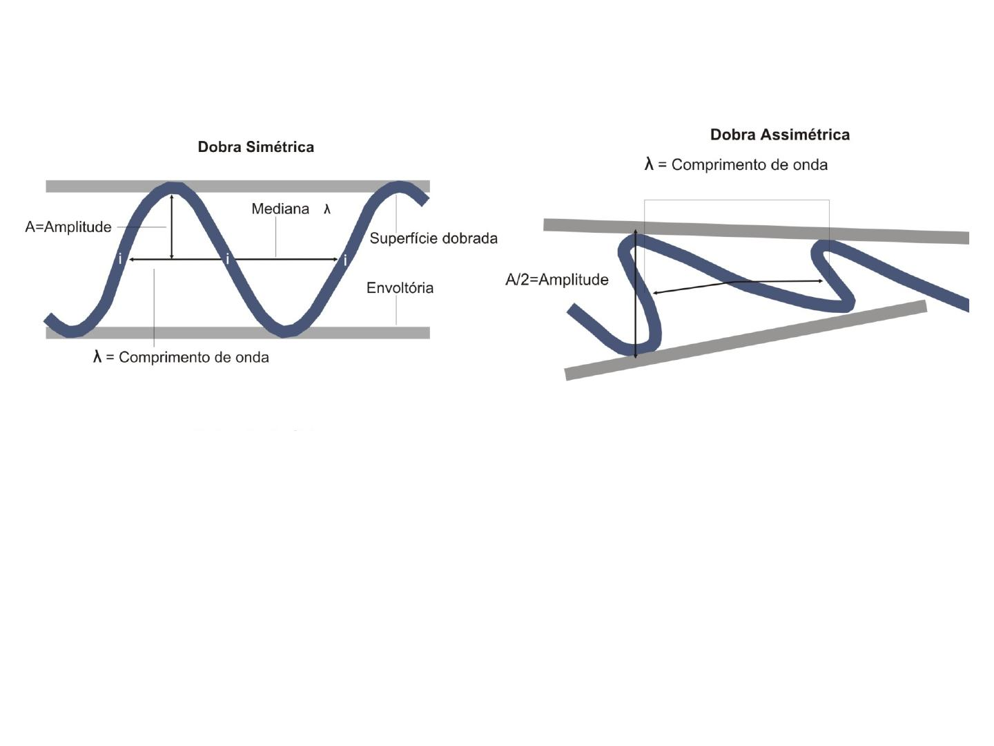

Asymmetric vs Irregular Wavy Shapes
# Source: AI Source: Provided by: [Data Path: Persons Table -> ID Column: 1, Name_En Column: Motasem Essam] -> From: [ChatGPT] on [7/25/2026]
These are not the same classification.
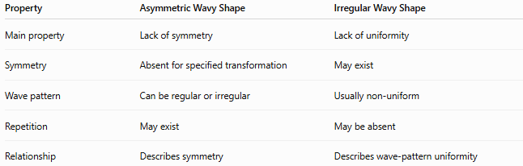
Property | Asymmetric Wavy Shape | Irregular Wavy Shape
Main property | Lack of symmetry | Lack of uniformity
Symmetry | Absent for specified transformation | May exist
Wave pattern | Can be regular or irregular | Usually non-uniform
Repetition | May exist | May be absent
Relationship | Describes symmetry | Describes wave-pattern uniformity
For example:
Regular + Asymmetric
is possible.
Likewise:
Irregular + Symmetric
is also possible.

Examples
# Source: AI Source: Provided by: [Data Path: Persons Table -> ID Column: 1, Name_En Column: Motasem Essam] -> From: [ChatGPT] on [7/25/2026]
Examples of asymmetric wavy shapes include:
- An open wave with unequal left and right sections.
- A closed organic outline with different-sized waves.
- A repeating wave pattern lacking reflection symmetry.
- An irregular freeform wave.
- A shape with symmetry in one portion but not the whole boundary.
- A closed wavy shape with uneven lobes.
- A directional wave pattern with no corresponding mirror image.

Classification Summary
# Source: AI Source: Provided by: [Data Path: Persons Table -> ID Column: 1, Name_En Column: Motasem Essam] -> From: [ChatGPT] on [7/25/2026]
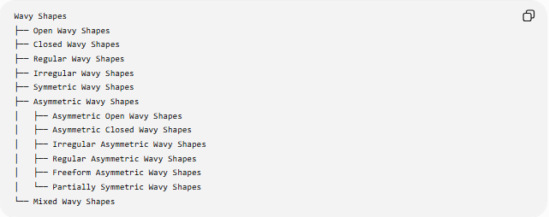
Wavy Shapes
├── Open Wavy Shapes
├── Closed Wavy Shapes
├── Regular Wavy Shapes
├── Irregular Wavy Shapes
├── Symmetric Wavy Shapes
├── Asymmetric Wavy Shapes
│ ├── Asymmetric Open Wavy Shapes
│ ├── Asymmetric Closed Wavy Shapes
│ ├── Irregular Asymmetric Wavy Shapes
│ ├── Regular Asymmetric Wavy Shapes
│ ├── Freeform Asymmetric Wavy Shapes
│ └── Partially Symmetric Wavy Shapes
└── Mixed Wavy Shapes
Classification Relationship
These properties can overlap:
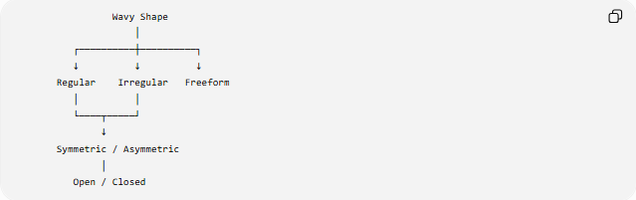
Wavy Shape
│
┌──────────┼──────────┐
↓ ↓ ↓
Regular Irregular Freeform
│ │
└────┬─────┘
↓
Symmetric / Asymmetric
│
Open / Closed
For example:
Irregular + Asymmetric + Closed + Wavy Shape
is a valid combined description.

Key Points
# Source: AI Source: Provided by: [Data Path: Persons Table -> ID Column: 1, Name_En Column: Motasem Essam] -> From: [ChatGPT] on [7/25/2026]
- An Asymmetric Wavy Shape lacks the specified symmetry.
- Its corresponding parts do not coincide under that transformation.
- It can be open or closed.
- It can be regular or irregular.
- Asymmetric does not mean irregular.
- A shape can have partial symmetry while being asymmetric as a whole.
- For reflection about the $y$-axis, symmetry requires:
$$f\left(-x\right)=f\left(x\right)$$
- For point symmetry about the origin:
$$f\left(-x\right)=-f\left(x\right)$$
- A closed asymmetric wavy shape still has an enclosed area.

Conclusion
# Source: AI Source: Provided by: [Data Path: Persons Table -> ID Column: 1, Name_En Column: Motasem Essam] -> From: [ChatGPT] on [7/25/2026]
An Asymmetric Wavy Shape is a wavy form that does not remain unchanged under the symmetry transformation being considered. Its lack of symmetry can result from differences in wave size, spacing, curvature, position, or overall arrangement. Asymmetry is an independent property from regularity, irregularity, and whether the shape is open or closed.

